**Pathfinder Tax Calculation Customizations**

# 1. Objects Modified

| **Object Type** | **Object ID** | **Object Name** |
| --- | --- | --- |
| Codeunit | 37032330 | Payroll Calculation |

# 2. Code Customizations

2.1. Method: CalculateDependentTax() - Codeunit PayrollCalculation

SSI2.00, DJ, 08/07/24 - Added Method CalculateDependentTax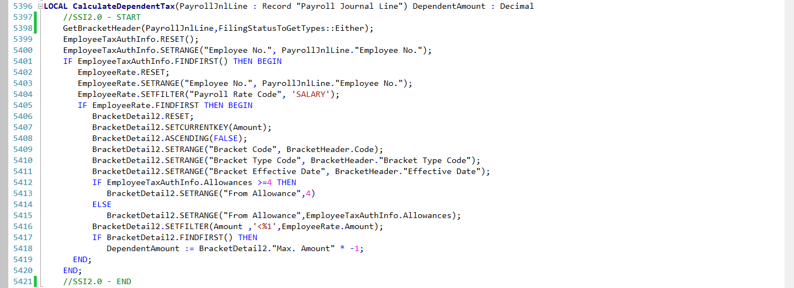

Purpose: This new method was added to calculate the additional tax amount based on the number of dependents.

2.2.Switch Case: 500 - APPLY DEPENDENT BRKT

SSI2.00, DJ, 08/07/24 - Added Switch Case 500 - APPLY DEPENDENT BRKT

Purpose :This is the switch case linked to the new method step **APPLY DEPENDENT BRKT**.

# 3. Testing Instructions

**Step 1**: Access Payroll Control

* Navigate to the Payroll Role Center page.
* Click on “**Payroll Controls**”

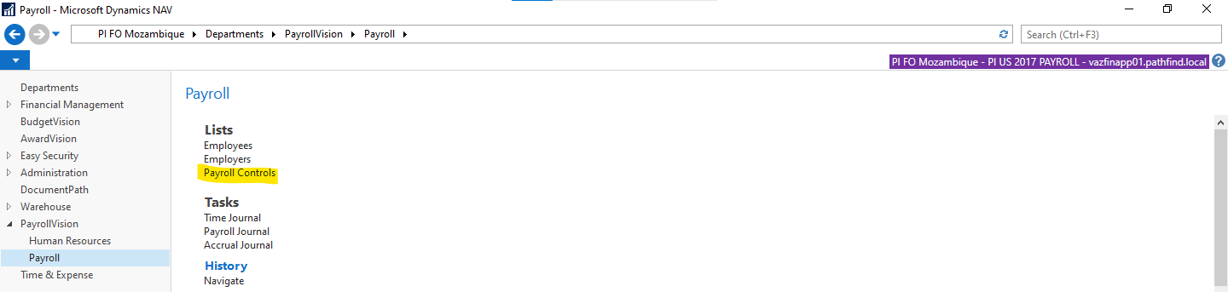

**Step 2**: Select the LIT Record

* Choose the LIT record.
* Click on the "**Calc Method**" action, which will redirect to the Payroll Calc Method page.

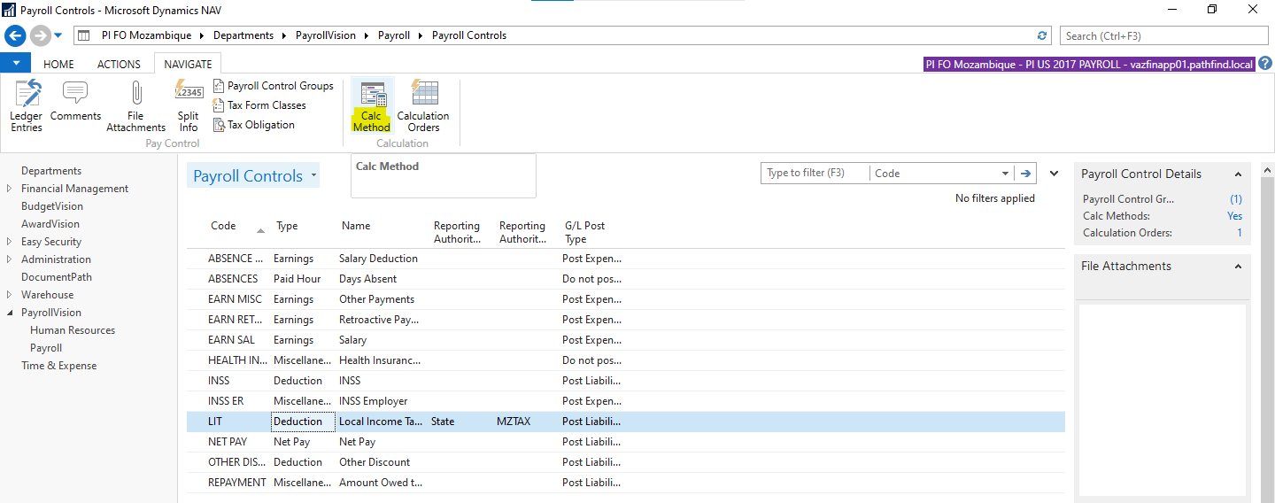

**Step 3**: Review the New Method Steps

* On the Payroll Calc Method page, select the last effective date.
* Click on the "**Steps**" action to view the method steps.

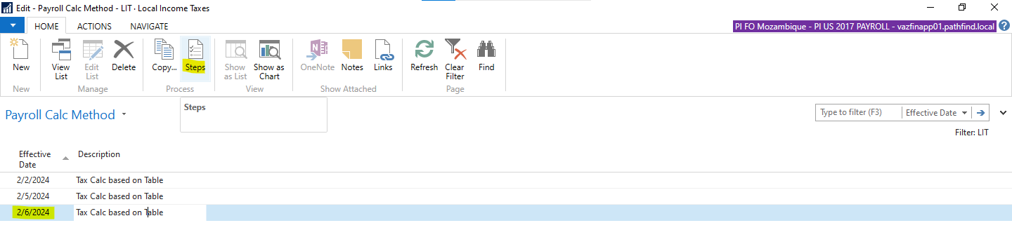

* Verify that two new method steps **APPLY DEPENDENT BRKT** and **ADD ADJUSTED TO AMT** have been added to calculate brackets based on the number of dependents.

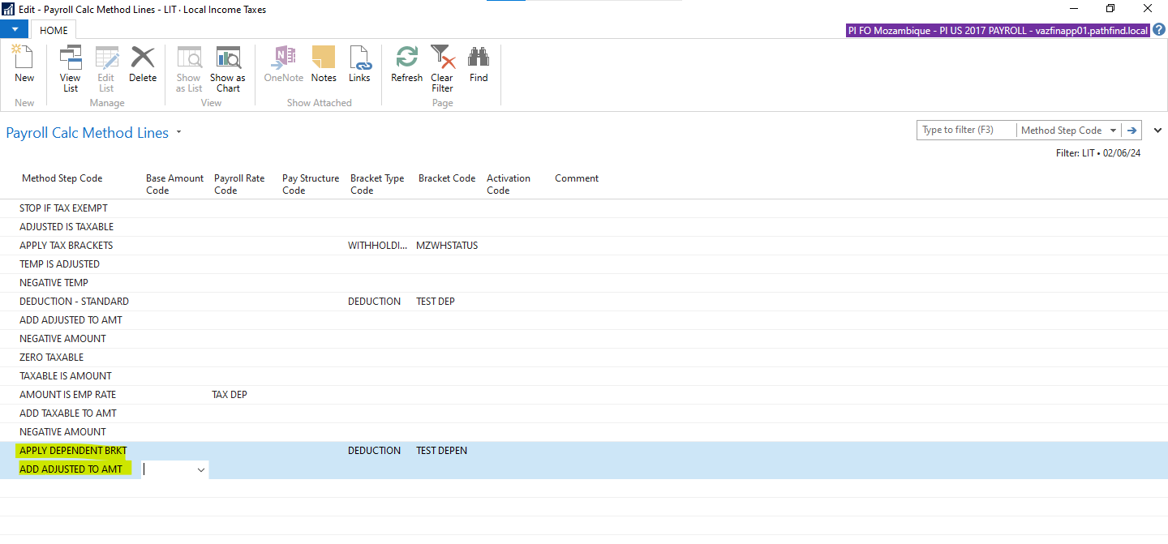

**Step 4**: Verify Calculations

* Navigate Back to Payroll Role Center Page and click on “**Payroll Journal**”.
* Click on the "**Calculate..**" action, which runs a report to create payroll journal lines for the employees specified.
* Verify the Payroll amount on the created journal lines.

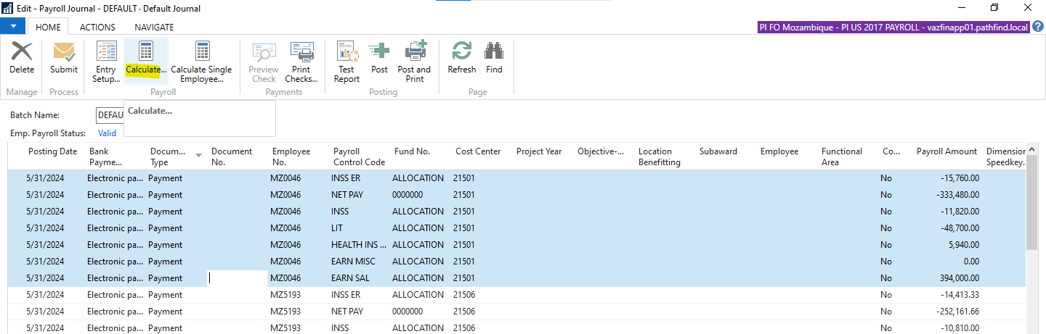

# 

# 

# 

# 4. Screenshots

## Before Customizations

This screenshot shows the system behavior prior to implementing the new tax calculation method.

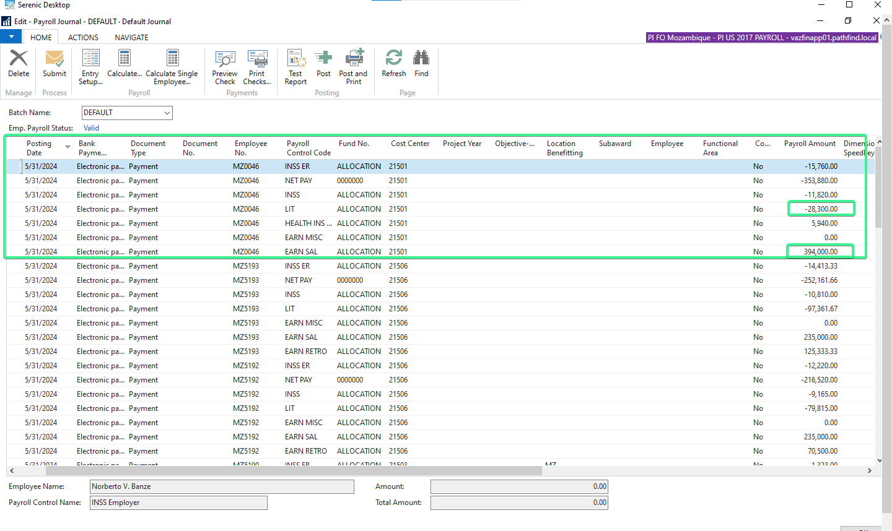

## After Customizations

This screenshot demonstrates the updated system behavior with the new tax calculation method in place.

